**Steps to create bootable USB in Windows :**

1. Download ‘Universal-USB-Installer’ from following link on Windows machine

<http://www.pendrivelinux.com/downloads/Universal-USB-Installer/Universal-USB-Installer-1.9.5.2.exe>

1. Select the Linux Distribution as ‘Ubuntu’ from the dropdown
2. Browse your iso file

If you don’t see the iso file at your path, as below

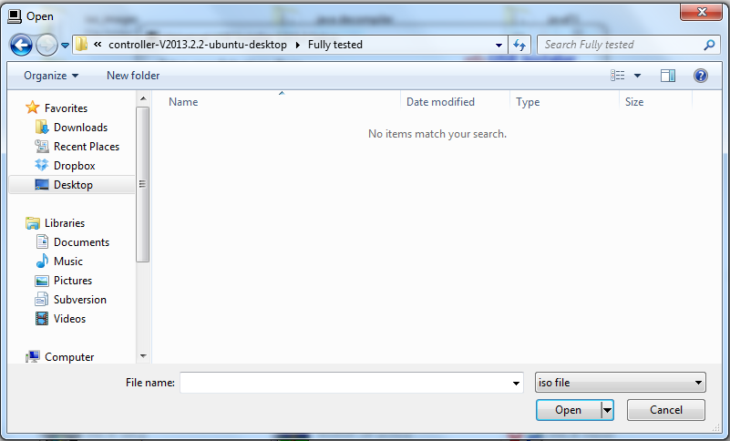

Search the ‘*.iso’ at File name field, as below

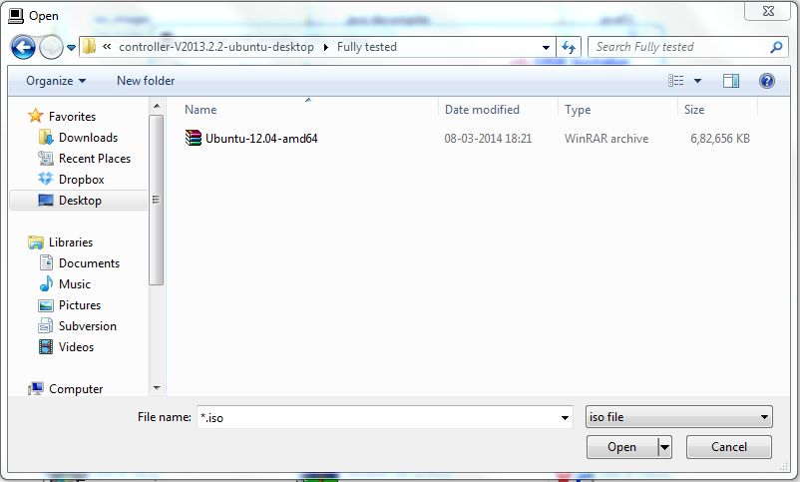

1. Select your USB device
2. Make sure to Check the ‘Format’ option
3. Click on the ‘Create’

Link for reference : <http://www.pendrivelinux.com/universal-usb-installer-easy-as-1-2-3/>